**Tracing Mobility; Cartography in Networked Space.**

**Landon Mackenzie (CAN)**

[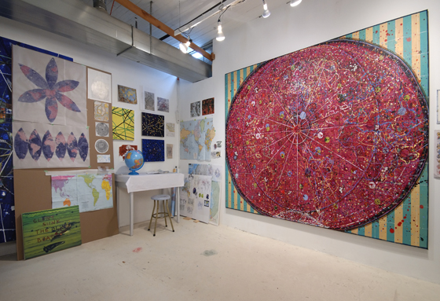](http://trampoline.org.uk/tracingmobility/wp-content/uploads/2011/10/Landon-Mackenzie.jpg)

**Vancouver As the Centre of the World, 2009**

For Landon Mackenzie, Vancouver As the Centre of the World (2009) is “a cross between an Elizabethan sea chart and a psychedelic poster.” The work was originally commissioned for the Vancouver 2010 Olympic Winter Games, and thus encouraged a charting of course. From Elizabethan sea charts to network mapping, Mackenzie embedded a quasi-history of cartography. Incorporated into the painting are drawings of Internet cable systems, shipping lanes, city ‘grids’ and network maps.

Factual and fictitious satellites swirl over top of her flat painted plane as she reorganised a global map around a new center, that of Vancouver. Erasing national boundaries and the distinctions between land and oceans, she also reproduced all continents several times in reference to the world turning daily, and slowly flowing into new formations as it has since the earth’s beginning. Challenging the ideology of standard maps, Mackenzie traces the continents directly from ‘old school’ globes to create more accurate representations of scale, while at the same time reconciling a methodology of plotting a circular sphere onto a flat rectangular surface.

[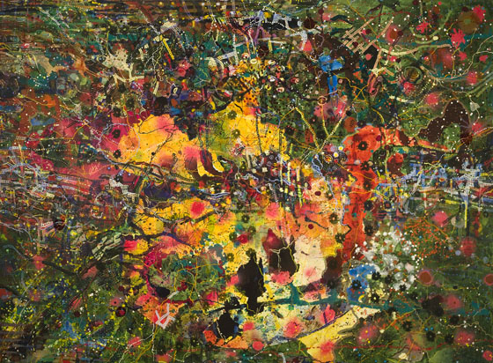](http://trampoline.org.uk/tracingmobility/wp-content/uploads/2011/10/Houbart-s-Hope.jpg)

**Houbart’s Hope (Green), Hope Advanced, Hope Dasht, 2001-2004**

Houbart’s Hope (Green), Hope Advanced, Hope Dasht is one of two-dozen paintings Landon Mackenzie has produced from 1993 to 2005 with the intention of remapping Canada. The artist began this project by situating Canada in the center of North America, in which the full Arctic tundra was included. Based on research in cartography, history, geography and lost secrets, each work in her trilogies is the same size in order to create a sense of cartographical continuity and filmic narrativity. For, in these re-mappings, various new forms come into play; Mackenzie overlays the real and the fictitious such that they can open up to new story lines. Incorporated into her abstract mappings are electrical and chemical storms, criss-crossing trains, various outposts and subsequent magnetic narratives.

Specifically, Houbart’s Hope (Green), Hope Advanced, Hope Dasht is derived from early 17th Century European exploration maps that were seeking a Northwest passage. The navigators gave names to various sites located along the Hudson’s Bay, some of which Mackenzie conjoins in her title. In the painting, the artist layers data that is both historical and contemporary, cartographical and whimsical. The work takes on another element of mapping, so-to-say, in terms of ‘brain mapping’ in the artist’s interest in neurology, a field she finds great parallels to hers as the worlds she creates take on a brain-like identity.